Civil war in [Burundi]

UNSC Resolution: | 1012
Date of adoption: | 29-August-1995
Operative paragraph: | 5
Demand number: | 1012.0511

[Philippe Rieder]

Wording of demand
Fully cooperate with the international commission of inquiry in the accomplishment of its mandate, including responding positively to requests from the commission for security, assistance and access in pursuing investigations

List of addressees of the demand

Government of Burundi, all parties within Burundi

Short-term compliance

Description of the addressee(s)’ conduct

“The representative of Rwanda [after the vote on 29 August 1995] said that Burundi was part of the Great Lakes region and as such its problems could not be resolved without taking into account the current events in other countries of the subregion. Unlike the other subregions of Africa, the countries of the Great Lakes had experienced the institutionalization of a culture of impunity. The region was now considered a powder keg and a source of refugees. He reiterated that the United Nations and the Security Council could not solve the problems of the subregion without involving the regional and subregional organizations. It was therefore necessary to provide them with material, technical and financial support so that they could better fulfil their role which was indispensable and complemented that of the United Nations and the Security Council. Noting that Burundians bore primary responsibility for their future, he appealed to the United Nations and to the international community to support the existing institutions in the country.” (The situation in Burundi, in: UNSC Repertoire 12th Supplement 1993-1995: Chapter VIII, p. 27)

“The Commission has started its investigation into the assassination of former President Melchior Ndadaye in October 1993. Two visits were made to the countryside during which members of the Commission interviewed prisoners held in connection with crimes related to the subsequent massacres. The Commission has also initiated a study of the judicial system.
(c) The Commission identified four major problems in the implementation of its mandate. The first is the period of time that has elapsed since the events under investigation. Perpetrators of crimes, witnesses and victims may have become refugees, displaced persons or died. Evidence may have been lost, suppressed or altered, while some evidence previously gathered may not conform with generally accepted judicial standards.
(d) Secondly, the ethnic polarization in the country is intensifying under the influence of extremists. In such circumstances of widespread hatred and fear, the Commission finds it difficult to obtain truthful, objective and reliable testimony.
(e) The general deterioration of the security situation in Burundi is the third problem and the one that poses the greatest obstacle to the work of the Commission. The Commission believes that the United Nations security personnel currently provided for its protection are inadequate. Moreover, it feels that reliance on the Burundese security forces for protection is likely to impede the Commission’s access to testimony and also compromise its credibility as an impartial international body.
(f) Finally, the Commission expresses serious concern about the inadequacy of the resources provided to it. In its view, the mandate entrusted to it necessitates additional staff to gather required evidence and undertake investigative work. Trained investigators, support staff and material resources are needed to enable it to accomplish its mandate within a reasonable period of time.” (LETTER DATED 3 JANUARY 1996 FROM THE SECRETARY-GENERAL ADDRESSED TO THE PRESIDENT OF THE SECURITY COUNCIL, (S/1996/8), 6 January 1996, p. 1f)

“The Council calls upon all concerned in Burundi to exercise maximum restraint and to refrain from all acts of violence. It reiterates that all who commit or authorize the commission of serious violations of international humanitarian law are individually responsible for such violations and should be held accountable. In this context, it stresses the importance it attaches to the work of the International Commission of Inquiry established pursuant to its resolution 1012 (1995) of 28 August 1995 and undertakes to study carefully the letter from the Secretary-General dated 3 January 1996 containing an interim report on that work.” (Statement by the President of the Security Council, (S/PRST/1996/1), 5 January 1996)

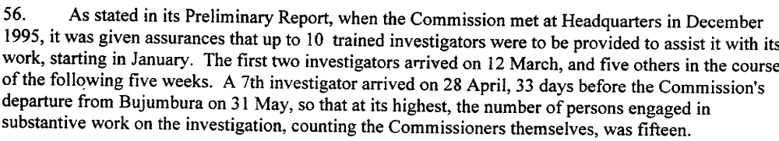
(Annex to Letter dated 25 July 1996 from the Secretary-General addressed to the President of the Security Council, transmitting the final report of the Commission of Inquiry,(S/1996/682), 22 August 1996, p. 15)

Assessment

Short-term compliance
No or marginal compliance (1) | X Medium low compliance (2) | Medium high compliance (3) | Full or almost full compliance (4)

Considerations underlying the assessment

Even though the Commission was able to travel to Burundi and was welcomed by the authorities there, its work was obstructed by the deteriorating security situation and the fact that it relied on the Burundese Security Forces for security, while the army of course was a party under investigation. The security of the Commission was later partly ensured by the military observers of the OAU.

Medium-term compliance

Description of the addressee(s)’ conduct

“He [the Representative of Egypt at the 3693rd meeting held on 5 March 1996] stated that the OAU had played an important role in Burundi since 1993 and had sent an observer mission for dual political and military purposes and its military observers were providing protection to the officials of the international Commission of Inquiry. Even though that role was not initially welcomed by certain parties in Burundi and even though it received no political or material support from other international organizations it had become one of the major axes of development reaffirming the importance of the regional organization’s support for containing crises and conflicts under Chapter VIII of the Charter.” (The situation in Burundi, in: Repertoire of the UNSC 1996-1999, 13th Supplement – Chapter VIII, p. 19)

“She [the Representative of the USA at the 3693rd meeting held on 5 March 1996] stated that it was an initiative designed to bolster the confidence of moderates in the Government of Burundi and elsewhere in society and could save thousands of lives. She also urged the Secretary-General to provide additional security and investigatory personnel to the Commission of Inquiry since Commission needed to complete its investigation into the events of the attempted coup d’état of 1993 and the subsequent ethnic violence.” (The situation in Burundi, in: Repertoire of the UNSC 1996-1999, 13th Supplement – Chapter VIII, p. 20f)

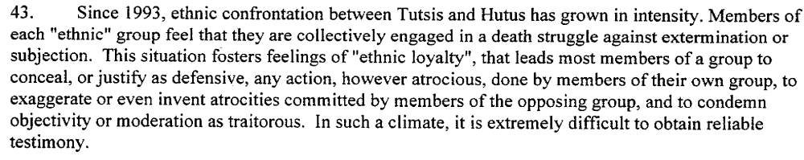
(Annex to Letter dated 25 July 1996 from the Secretary-General addressed to the President of the Security Council, transmitting the final report of the Commission of Inquiry,(S/1996/682), 22 August 1996, p. 13)

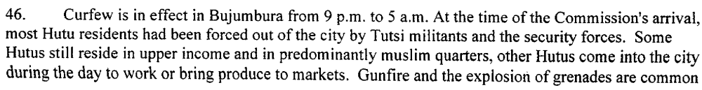
(Annex to Letter dated 25 July 1996 from the Secretary-General addressed to the President of the Security Council, transmitting the final report of the Commission of Inquiry,(S/1996/682), 22 August 1996, p. 13f)

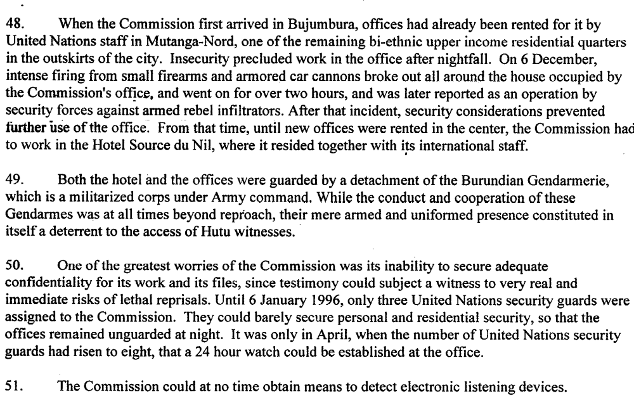
(Annex to Letter dated 25 July 1996 from the Secretary-General addressed to the President of the Security Council, transmitting the final report of the Commission of Inquiry,(S/1996/682), 22 August 1996, p. 14)

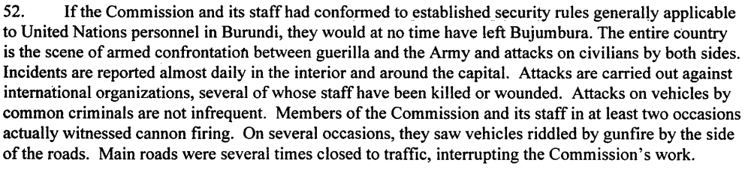
(Annex to Letter dated 25 July 1996 from the Secretary-General addressed to the President of the Security Council, transmitting the final report of the Commission of Inquiry,(S/1996/682), 22 August 1996, p. 14)

(Annex to Letter dated 25 July 1996 from the Secretary-General addressed to the President of the Security Council, transmitting the final report of the Commission of Inquiry,(S/1996/682), 22 August 1996, p. 15)

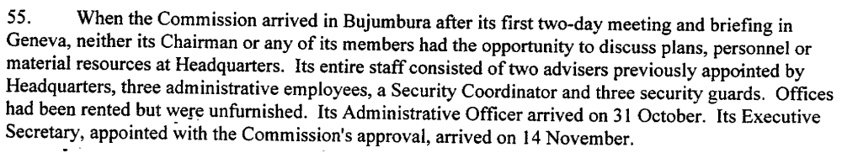(Annex to Letter dated 25 July 1996 from the Secretary-General addressed to the President of the Security Council, transmitting the final report of the Commission of Inquiry,(S/1996/682), 22 August 1996, p. 15)

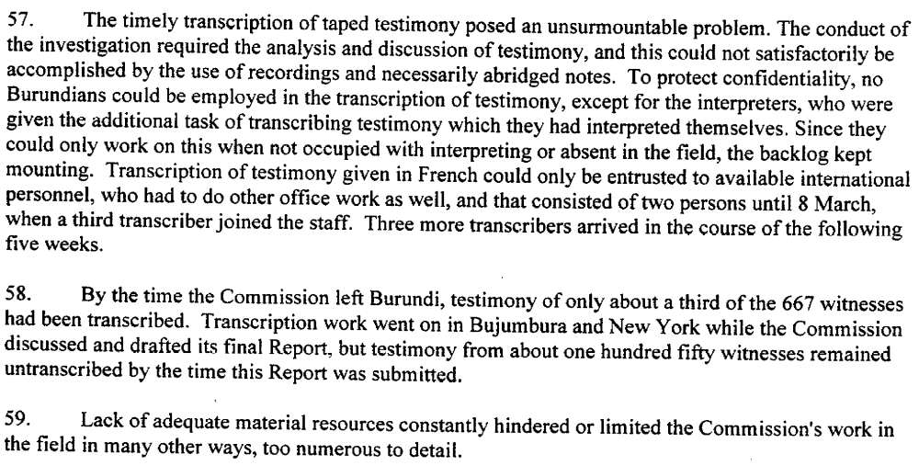
(Annex to Letter dated 25 July 1996 from the Secretary-General addressed to the President of the Security Council, transmitting the final report of the Commission of Inquiry,(S/1996/682), 22 August 1996, p. 15)

Assessment

Medium-term compliance
No or marginal compliance (1) | X Medium low compliance (2) | Medium high compliance (3) | Full or almost full compliance (4)

Considerations underlying the assessment

Even though the Government’s security forces did their best to ensure the security of the Commission, the precarious security situation, the ethnic polarization clouding the testimonies as well as the inadequacy of resources in the war-torn country diminished the quality of its work significantly.

Depth of Demand

Assessment

Level of depth of demand
Low depth of demand (1) | X Medium depth of demand (2) | High depth of demand (3)

Considerations underlying the assessment

Throughout 1995 and 1996, war raged inside Burundi. Ensuring the security of the Commission and allowing it access to certain areas was a dangerous task. Also, both sides did not want to have international witnesses to the massacres they committed.

Level of confidence about coding decisions

Level of confidence about coding decision
Extremely high | X High | Moderate

Comments to IPI (if any)

